CSCI 1900 - Homework 20 - B

Section 13.2: Finite State Machines (19)
- Given the following formal description of a finite state machine $FSM=\left(S, A, f,s_{0}, F\right)$, where
$S= \left\{s_{0}, s_{1}, s_{2 }\right\}$
$$A= \left\{a, b\right\}$$
$$F= \left\{s_{2}\right\}$$
 | a | b
s₀  $$f=$$ | s₁ | s₀
s₁ | s₁ | s₂
s₂ | s₁ | s₀

  - Draw the diagraph of the FSM (1)
  - Describe the strings that are accepted by FSM (1)
- Write the formal description of the following FSM, which accepts strings containing at least 2 a ’s. (5)

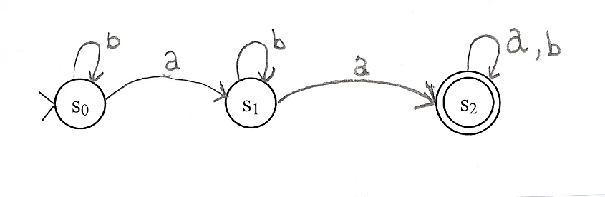
- Give the formal description and draw the finite state machine with an input alphabet {a, b} and accepts all strings that begin with a and end with b. (6)
- Give the formal description and draw the diagraph of the finite state machine with an input alphabet {0, 1} and accepts all strings that contain an odd number of 0 ’s. (6)

